Second lieutenant Ecatherina Teodoroiu, the first female officer in the Romanian Army, fell heroically on duty in the battles of the First World War

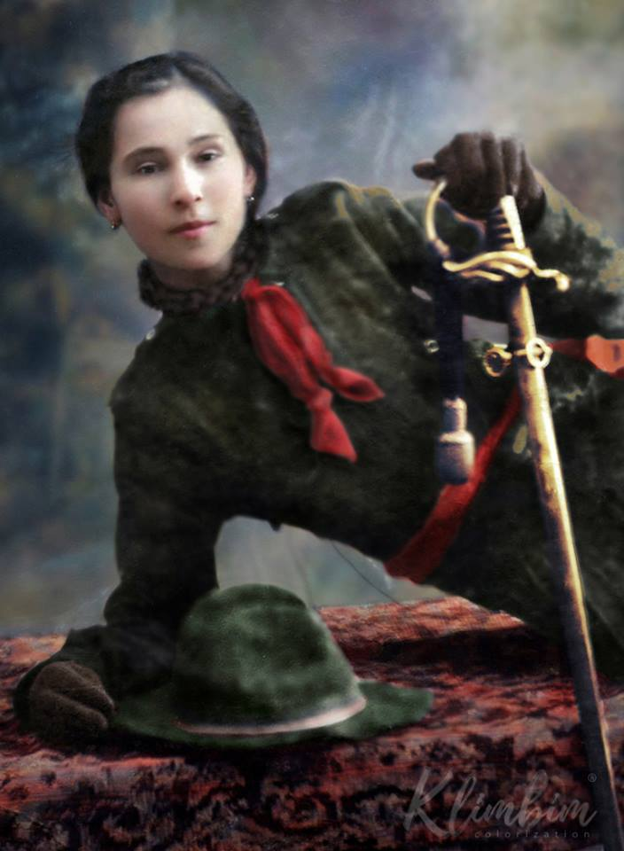

Ecaterina Teodoriu is an emblematic figure of the history of the Romanian
Army's participation in the First World War. Ecaterina fought and died in the fights of the first world conflagration, being recognized as a heroine of Romania.

Ecaterina Teodoroiu's first connection with military life was recorded in 1913, at the age of 19 when she was a pupil, she enrolled in the "Romanian Scout Association".

From 1913, Ecaterina was transferred to the coordination of the Romanian Red Cross, and in August 1916, she was detached to take care of the wounded in the Târgu-Jiu hospital, in the context of Romania's entry into the First World War (27/28 August 1916).

Ecaterina witnessed the death of her brother, Nicolae, on the battlefield, on November14, 1916. Convinced that war is not a play, but the conscience of supreme sacrifice, she tried several times to participate in the front as an active soldier. Every time she was denied, telling her that her place was in the hospital. However, Ecaterina decided to leave on the battlefield in the front line. The commanders gave up her insistence and got her to fight with the soldiers.

It was noted in the battles of the Jiu river on October 10, 1916, when the
Romanian army rejected the attack of the German army, being seriously injured – the shrapnel from a bomb shell led to the fracture of her left hip.

From a simple soldier, as she enlisted in August 1916, one year later she returned to the frontline, at the head of the platoon she commanded, as an officer. Second lieutenant Ecaterina Teodoroiu, the first female officer in the Romanian army! For the deeds of arms and the courage proved on the battlefield, King of Romania, Ferdinand, gave her two precious and earnest awards: the Order of the "Virtue of the Scout War in Gold" and the Order "Military Virtue of War, Second Class"

On August 22, 1917, during the Battle of Mărăşeşti, won by the Romanian
Army at the expense of the German Army, Ecaterina Teodoroiu fought heroically. She stood up on the trench parapet to observe the movements of the enemy troops through the binoculars, ordering the soldiers she commanded to repel: "Ahead men, do not give up, you are with me!" At that time, two bullets shot by a German machine gun hit Ecaterina on the left side of her chest, causing her death.

Colonel Pomponiu, commander of the 43/59 Infantry Regiment, quoted
Ecaterina in the Day of the Day Order, mentioning among other things: "She gave her life with the simplicity of true heroism, not to get the apotheosis of a word, but because so her soul believed that the duty of life was fulfilled."

On August 23, 1917, Ecaterina was buried with a military parade.

